A000-Mex-Colima-Seated Female-Tuxcacuesco-Ortices type-Terra cotta-300 BCE-300 CE

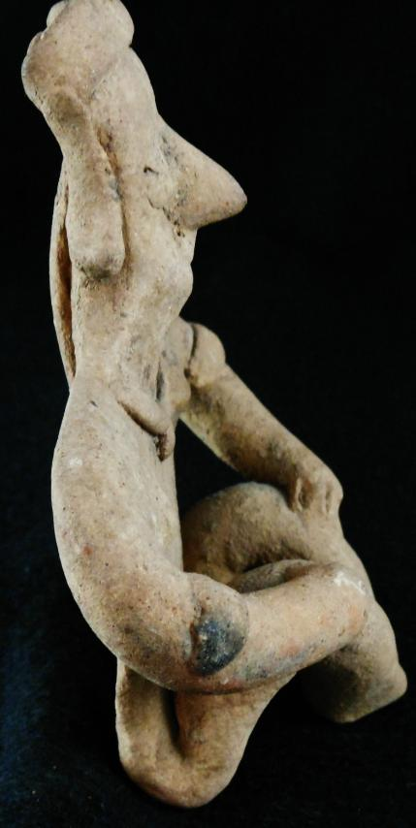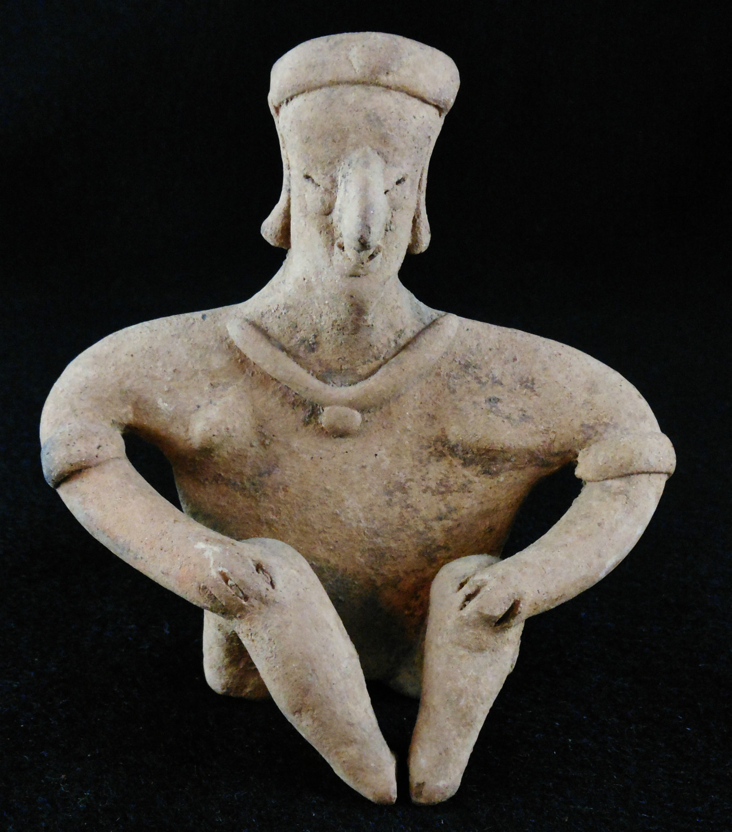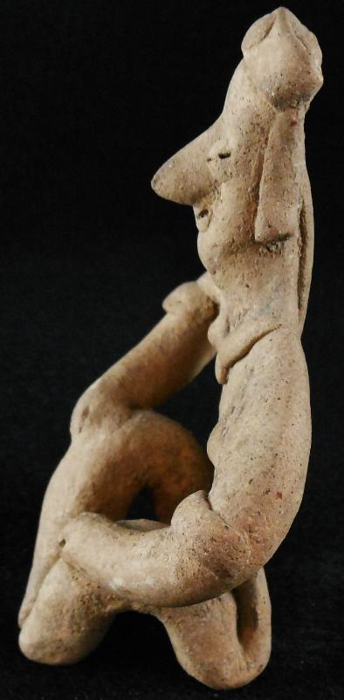

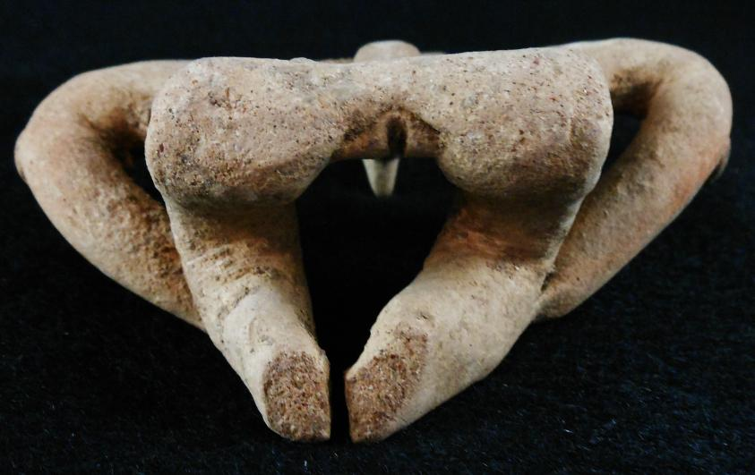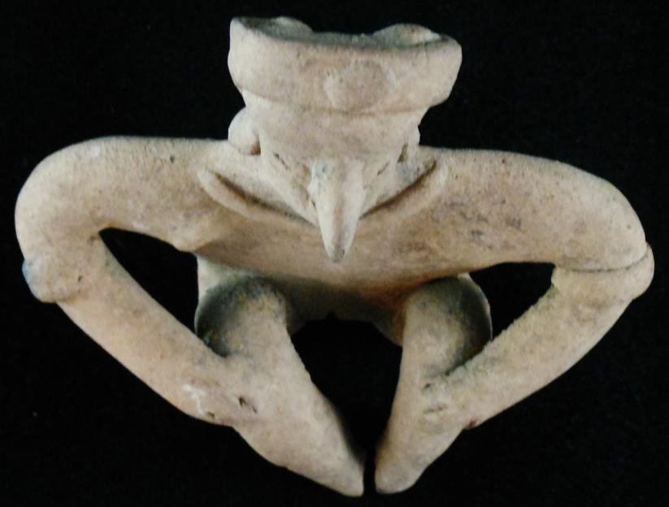

Figs. 1-5. Mex-Colima-Seated Female-Tuxcacuesco-Ortices type-Terra cotta-300 BCE-300 CE

Case No.: 9

**Accession No.**

**Formal Label:** Mex-Colima-Seated Female-Tuxcacuesco-Ortices type-Terra cotta-300 BCE-300 CE

**Display Description:**

Colima Tuxcacuesco-Ortices type seated female, wearing head band with central ornament, arm bands, ear ornaments (possibly in the form of copper tinkler bells), necklace with pendant and a shoulder-length queue at the back. This figure is sitting with a purposeful countenance as though receiving the viewer. Colima figures can be visually divided into three categories: flat, highly-burnished brown-buff figures with bowed legs, solid unburnished figures in three dimensional poses and the flat, unslipped and unburnished types of which this is an example and is similar in ceramic treatment to the one in Kan, Meighan and Nicholson 1989: pl. 129, p. 140, also see p. 27.

Case No.: 9

**Accession No.**

**Formal Label:**

**Display Description:**

Large Seated Pre-Columbian Colima Ruling Figure, male. Distinctive turban style headdress, ear spools, a necklace, epaulets, a waist band and a kilt. The nose, necklace and right foot and head have been reattached. Distinctive treatment and modeling of the eyes, mouth and hands. Originally deposited in a shaft tomb.

**LC Classification: F1219.1.C75**

**Date or Time Horizon:**

**Geographical Area:**

**Map:**

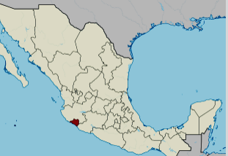

**Location of Colima, Mexico. https://upload.wikimedia.org/wikipedia/commons/thumb/a/a6/Colima_in_Mexico_%28location_map_scheme%29.svg/375px-Colima_in_Mexico_%28location_map_scheme%29.svg.png**

**GPS coordinates:** [19°10′N 103°53′W](https://tools.wmflabs.org/geohack/geohack.php?pagename=Colima&params=19_10_N_103_53_W_type:adm1st_region:MX)

**Cultural Affiliation:**

**Media:**

**Dimensions:** 5" high

**Weight:**

**Condition:**

**Provenance:** Originally deposited in a shaft tomb. Recovered from the ancient Colima culture in Western Mexico prior to 1970.

**Discussion:**

The Los Ortices period (500-300 BCE) established elements of the Colima culture, including shaft tombs and a distinctive ceramic style called *rojo bruñido,* or burnished red. The following Comala or Colima culture developed at the Comala site (300-300 CE). The Colima people perfected burnished red pottery *rojo bruñido* and produced terra cotta figurines of people and animals with distinctive fluid lines. The Comala site shows influence from Teotihuacan. Around 500 CE, another site in Armería developed along the river of the same name.

**References:**

Kan, Michael, Clement Meighan, H. B. Nicholson. 1989*. Sculpture of ancient west Mexico: Nayarit, Jalisco, Colima. A catalogue of the Proctor Stafford Collection at the Los Angeles County Museum of Art*. Albuquerque: Los Angeles County Museum of Art in association with University of New Mexico Press.

Reynolds, Richard D. 1993. *The Ancient Art of Colima, Mexico*. Walnut Creek, Calif.: Squibob Press.

|  |
| --- |
| **Ralph J Coffman Jr**  149 Atlantic Ave  Swampscott MA 01907-2427  United States |

## Order details

|  |  |  |  |
| --- | --- | --- | --- |
| **Item title** | **Available actions** | **Shipping & handling (estimated delivery*)** | **Price** |

[Printer version](http://payments.ebay.com/ws/eBayISAPI.dll?ViewPaymentStatus&transid=0&userloginid=802-867&orderid=123872550012&printerversion=true&itemid=150954438788)

|  |  |  |
| --- | --- | --- |
| Seller: | [**Member id** meantiques1](http://myworld.ebay.com/meantiques1) ( [**Feedback Score Of** 4444](http://feedback.ebay.com/ws/eBayISAPI.dll?ViewFeedback&userid=meantiques1)) | [Contact seller](http://contact.ebay.com/ws/eBayISAPI.dll?ShowCoreAskSellerQuestion&frm=3998&iid=0&redirect=0&requested=meantiques1) |

|  |  |  |  |  |
| --- | --- | --- | --- | --- |
| **Order # 123872550012**  Paid on Dec-02-12 via PayPal | | | | |
|  |  | |  | | --- | |  | | |  |  | | --- | --- | | [Contact seller](http://contact.ebay.com/ws/eBayISAPI.dll?ShowCoreAskSellerQuestion&frm=3998&iid=150954438788&redirect=0&requested=meantiques1) |  | | |  |  |

|  |  |  |  |  |  |  |  |  |
| --- | --- | --- | --- | --- | --- | --- | --- | --- |
|  | [**Item Title:**Authentic Pre-Columbian Standing Female Figure With Shoulder Jewels**- opens in a new window or tab**](http://cgi.ebay.com/ws/eBayISAPI.dll?ViewItem&item=150954438788)  **Item Id:**150954438788 - Price: US $113.50  Quantity:1  Having a problem with this purchase? [We can help](javascript:;) | |  | | --- | |  | | |  |  | | --- | --- | | [Leave feedback](http://feedback.ebay.com/ws/eBayISAPI.dll?LeaveFeedbackShow&useridfrom=802-867&useridto=meantiques1&item=150954438788&transactid=0) |  | | | Expedited Shipping : **US $15.00**  USPS Priority Mail Large Flat Rate Box®  Estimated delivery: December 8 - December 10  **Package 1 of 1**    Shipment details: [9407409699938305305470](javascript:;) | US $113.50 |
|  | [**Item Title:**Authentic Pre-Columbian Effigy Pot With Geometric Decoration**- opens in a new window or tab**](http://cgi.ebay.com/ws/eBayISAPI.dll?ViewItem&item=160929763376)  **Item Id:**160929763376 - Price: US $102.50  Quantity:1  Having a problem with this purchase? [We can help](javascript:;) | |  | | --- | |  | | |  |  | | --- | --- | | [Leave feedback](http://feedback.ebay.com/ws/eBayISAPI.dll?LeaveFeedbackShow&useridfrom=802-867&useridto=meantiques1&item=160929763376&transactid=0) |  | | | Shipped with item above  **Package 1 of 1**    Shipment details: [9407409699938305305470](javascript:;) | US $102.50 |

|  |  |  |  |  |  |  |  |  |
| --- | --- | --- | --- | --- | --- | --- | --- | --- |
|  | [**Item Title:**Authentic Pre-Columbian Male Figure WithTwined Headdress**- opens in a new window or tab**](http://cgi.ebay.com/ws/eBayISAPI.dll?ViewItem&item=160929776569)  **Item Id:**160929776569 - Price: US $62.00  Quantity:1  Having a problem with this purchase? [We can help](javascript:;) | |  | | --- | |  | | |  |  | | --- | --- | | [Leave feedback](http://feedback.ebay.com/ws/eBayISAPI.dll?LeaveFeedbackShow&useridfrom=802-867&useridto=meantiques1&item=160929776569&transactid=0) |  | | | Shipped with item above  **Package 1 of 1**    Shipment details: [9407409699938305305470](javascript:;) | US $62.00 |
|  | [**Item Title:**Authentic Pre-Columbian Seated Female Figure With Neck Jewel**- opens in a new window or tab**](http://cgi.ebay.com/ws/eBayISAPI.dll?ViewItem&item=160929782231)  **Item Id:**160929782231 - Price: US $132.50  Quantity:1  Having a problem with this purchase? [We can help](javascript:;) | |  | | --- | |  | | |  |  | | --- | --- | | [Leave feedback](http://feedback.ebay.com/ws/eBayISAPI.dll?LeaveFeedbackShow&useridfrom=802-867&useridto=meantiques1&item=160929782231&transactid=0) |  | | | Shipped with item above  **Package 1 of 1**    Shipment details: [9407409699938305305470](javascript:;) | US $132.50 |



|  |  |  |  |  |
| --- | --- | --- | --- | --- |
|  | | |  | |
|  |  | |  | | --- | |  | | |  |